April 17, 2023

To Whom It May Concern:

It gives me great pleasure to write this letter of recommendation for Anthony Wurst for the internship at your company.

I have known Anthony for one semester. He took a Managerial Finance course (titled “Economics and Finance II”) from me, which gives me an opportunity to interact with him very intensively in the past 3 months. He always came prepared with the reading assignments, and was a good participant in class. I think this shows his level of commitment to improving his knowledge. Noticeably, Anthony often impressed me a lot with his thoughtful questions in class.

Anthony has excellent communication skills. In addition, he is extremely organized, reliable and hard-working. During this semester, one financial statement analysis project was assigned to students, where students need to analyze financial ratios in the context of a firm’s decisions concerning risk and return, capital structure choices, competition strategy in its industry and market context. Anthony shows his ability to appropriately apply Corporate Finance theory to real world practice. He can work both independently and in group. He is also very capable of team leadership. He accomplished tasks in a courteous and timely manner.

Anthony has extensive previous working experience. He was the founder and CEO of the Dominion Pest Control Services and was a board member of the Washington State Pest Management Association.

Anthony is a very personable, humble and engaging. He is open-minded and intellectually curious, and he responds well to constructive criticisms. Anthony has my highest recommendation.

If I can provide additional information to support Anthony’s application, please feel free to call me at 503-370-6883, or email me at ygu@willamette.edu.

Sincerely yours,

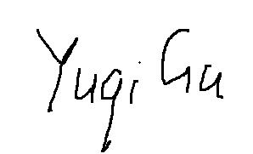

Yuqi (George) Gu
Assistant Professor of Finance
Atkinson Graduate School of Management
Willamette University

